AI Camera 2.0 Basic Projects

Lesson 6: Voice Command Recognition
Ages: 12 and up
Duration: 45 minutes

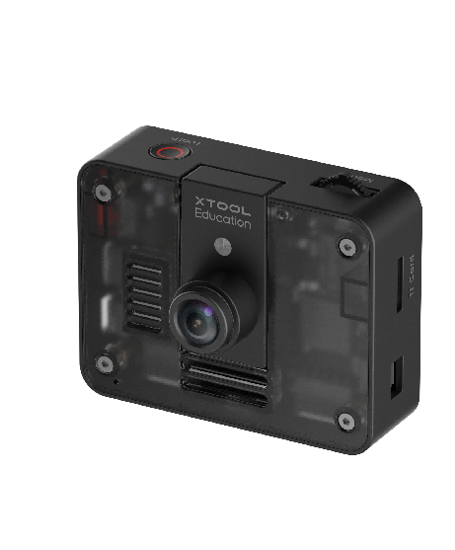

Objectives:
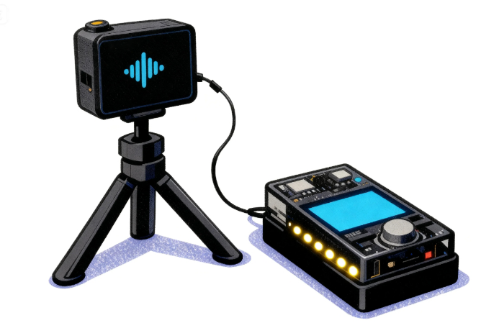
By the end of class, students will be able to:
- Understand the fundamental principles and workflow of speech recognition technology
- Master the basic methods of using AI Camera for voice command recognition
- Apply conditional judgment and event handling logic to implement voice-controlled interactive applications

Overview
This course guides students to explore the speech recognition capabilities of AI Camera and experience the application of artificial intelligence in voice interaction. Students will learn how to configure speech recognition parameters and program CyberPi to perform corresponding actions or feedback based on different voice commands. Through this project, students will understand the basic principles of speech recognition technology and consider its practical applications in daily life.

Pre-lesson Checklist
For the teacher:
- Computer with mBlock installed and tested;
- AI Camera, CyberPi, and connecting cables;
- Ensure relatively quiet classroom environment to facilitate speech recognition;
For the students:
- Computer with mBlock installed and ready;
- One set of CyberPi and AI Camera per group;
- Connecting cables;
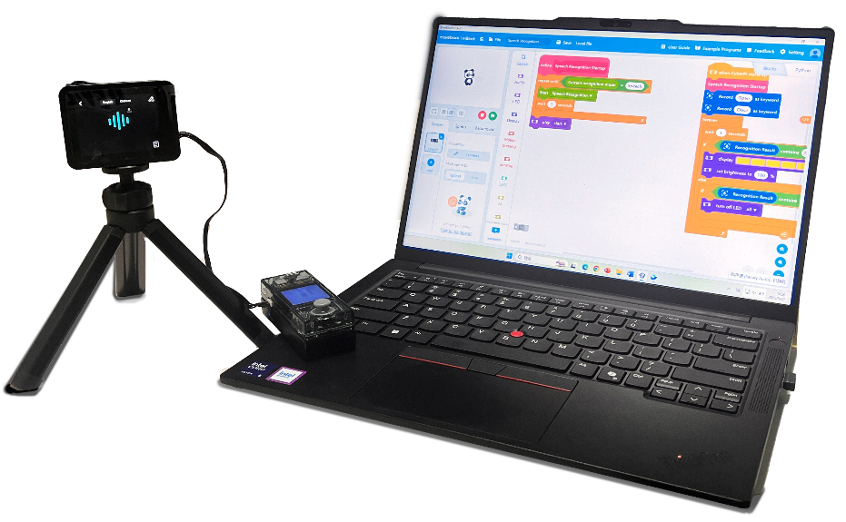

Agenda (45minutes)
Duration | Content
5 minutes | Section 1 - Introduction  - Demonstrate how the AI Camera recognizes voice commands and controls CyberPi to perform corresponding responses;  - Pose the question: "How does the AI Camera 'hear' and 'understand' what we say?"
10 minutes | Section 2 - Explore  - Understand the basic principles of speech recognition: audio signal processing and semantic analysis;
15 minutes | Section 3 - Create and practice  - Set up the programming environment and activate the speech recognition function;  - Configure voice command vocabulary and recognition parameters;  - Program to implement voice-controlled interactive functionality;
10 minutes | Section 4 - Presentation  - Invite 2-3 groups of students to demonstrate their voice interaction projects;
5 minutes | Section 5 - Evaluate  - Discuss application scenarios and development prospects of speech recognition technology;

Activities

Section 1 - Introduction
In this lesson, we will explore the speech recognition capabilities of the AI Camera, enabling it to understand and respond to our voice commands. When we say "turn on the light" to the camera, the CyberPi's LED will illuminate; when we say "show a smiley face," an emoji will appear on the screen. How is this technology implemented? Let’s begin today’s journey of exploration.

Section 2 - Explore
The AI Camera's ability to quickly read tag information relies on a technology called Tag Detection, which is based on pattern encoding and ID decoding.
Speech recognition technology enables computers to "understand" human language through a three-step process: first, acoustic signal processing, where a microphone captures sound and converts analog waveforms into digital signals; second, feature extraction, where the system analyzes sound characteristics like frequency and amplitude to identify key information; and finally, pattern matching, where the extracted features are compared against pre-stored voice models to determine the corresponding text commands.

Section 3 – Create and practice
In this section, students will establish the programming foundation, configure recognition parameters, and develop responsive voice commands to enable meaningful human-machine communication.
Step 1: Set up the programming environment and activate speech recognition. Add the [AI Camera 2.0] extension modules in mBlock, write an initialization program, and configure the [Keywords] for speech recognition. | 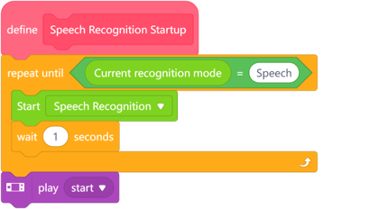
Step 2: Implement voice-controlled interaction. Program corresponding action responses—such as controlling LED lights, displaying emojis, or playing sounds—when specific keywords are recognized, enabling basic human-machine voice interaction functionality. | 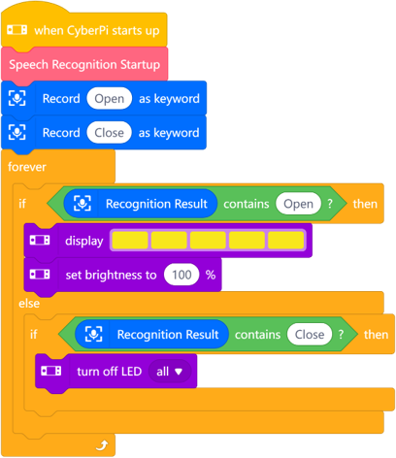

Section 4 - Presentation
In this session, each group is invited to demonstrate their completed voice interaction project. They will showcase the operational effect of the speech recognition system and briefly explain their design approach.
After 2-3 groups have presented, the teacher will facilitate a discussion comparing the differences and similarities in design concepts and technical implementations among the groups. Which designs are worth learning from and adopting? Beyond classroom projects, in what real-world scenarios can speech recognition technology be applied?

Section 5 - Evaluate
Now let's review some key points in this lesson.
- What were the main challenges encountered in developing the speech recognition project?
- How might speech recognition technology evolve in the future, and what changes could it bring to our daily lives?

